
u|Lg ;f];fO6L klAns :s'n
D-
/Tggu/–&, ;f}/fxf lrtjg
jflif{s परीक्षा—@)*@
sIff M– o'=s]=hL समय - @ 3+= k"0f{fÍM– %) ljifoM– g]kfnL
gfd : ====================================================/f]n g+=============;]S;g M ================
_________________________ ______________________ s'n k|fKtfÍ :
lg/LIfssf] ;xL k/LIfssf] ;xL
!= cfwf cIf/n] ag]sf] zAbx? n]Vg'xf];\ . -#_

@= vfnL 7fFp e/L cg'R5]b k"/f ug'{xf];\ . -$_
d]/f] gfd xf] . d
jif{sL÷jif{sf] ePF . d sIffdf k9\5' . d]/f] dgkg]{ /ª xf] .
#= jfSo k9]/ l7s lrqdf /ª eg{'xf];\ . -%_
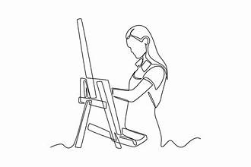
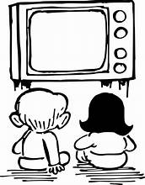
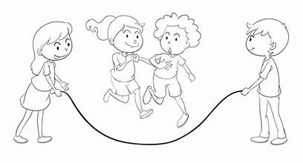
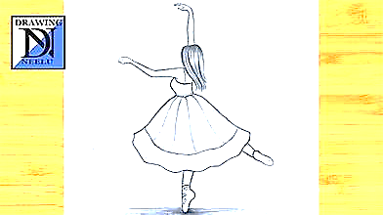

xfdL 6L=eL x]b}{{ 5f}F .
s]6L gfRb} 5] .
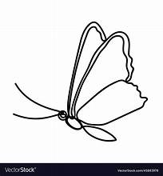
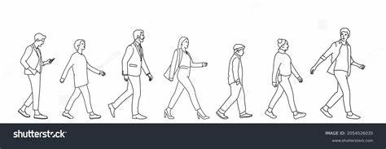
k'tln p8\bf} 5 .
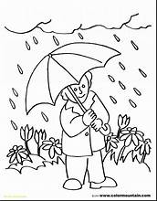

k'tnL p8\b} 5 .
Dfflg;x? lxF8\bf} 5g\ .

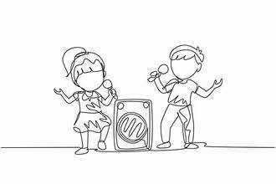
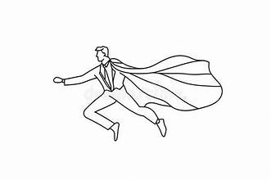

xfdL uLt ufFpb} 5f} .

$=sf]÷s] s:tf] 5 k9\g'xf];\ / l7s -✔_ jf a]l7s -❌_ lrGx nufpg'xf];\ . -%_
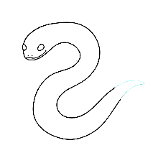
Uff]nf] r'/f
;fgf] an
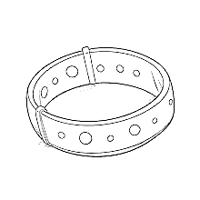
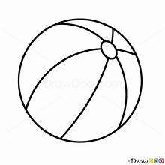

Nffdf] ;{k

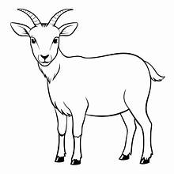

Dff]6f] afv\f

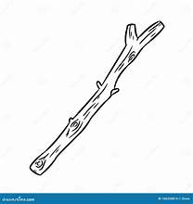

Nffdf] nf}/f]

%= zAbx? hf]8]/ jfSo agfpg'xf];\ . -%_
Ufg v]n
Kfn ksfpm
x]/
Gff} df}/L
nf}sf sf}jf
v]nf}gf

^= zAb agfpm . -%_
;lh
sd
sf]bf
uf]7f
cf]l;
nf]

&= lbOPsf] ;d'xaf6 nofTds gePsf zAbnfO{ a]l7s -❌_ lrGX nufpg'xf];\ . -%_
w[t d[t
u[x
cfs[lt k|s[lt
k[ys
Dfft[ d[u
lkt[

Clif s[kf
s[lif

j[If C0f
t[0f

*= pN6f] cy{ cfpg] zAbx? hf]8f ldnfpg'xf]';\ . -^_
7"nf] xf]rf]
cUnf] ;fgf]
;kmf 5f]6f]
nfdf] kmf]xf]/
gofF kftnf]
(= w]/}nfO Ps agfP/ n]Vg'xf];\ . -^_
l;dLx?Ö
dflg;x?Ö
kmnx? Ö
df5fx?Ö
tf/fx?Ö
r/fx?Ö
!)= jfSo k9\g'xf];\ / z'b\w jf cz'b\w x]/L l7s -✔_ jf a]l7s -❌_ lrGx nufpg'xf];\ . -^_
af/Ldf l;dLx? 5g\ .
3/df knª 5g\ .
xftdf r'/fx? 5 .
7]nfdf d]jf 5 .
a;df dflg;x? 5g\ .
emf]nfdf lstfax? 5g\ .
;dfKt

